# **COLLEGE BUDDY**

### **A PROJECT REPORT**

#### **Submitted by**

## ADITYA

#### **in partial fulfillment for the award of the degree of**

## BACHELOR OF ENGINEERING

**IN**

COMPUTER SCIENCE



**Chandigarh University**

MAY 2022

# **COLLEGE BUDDY**

### **A PROJECT REPORT**

#### **Submitted by**

## ADITYA (20BCS5209)

## KANISHK KUMAR (20BCS5216)

## KUSHAGRA (20BCS5221)

#### **in partial fulfillment for the award of the degree of**

## BACHELOR OF ENGINEERING

**IN**

COMPUTER SCIENCE



**Chandigarh University**

MAY 2022



## BONAFIDE CERTIFICATE

Certified that this project report **“COLLEGE BUDDY”** is the Bonafide work of “**Aditya, Kanishk Kumar, Kushagra”** who carried out the project work under my/our supervision.

**SIGNATURE SIGNATURE**

Mrs. Divya Narula Dr. Punit Soni

**SUPERVISOR HEAD OF THE**

**DEPARTMENT**

BE-CSE BE-CSE

Submitted for the project viva-voce examination held on 19/05/2022

**INTERNAL EXAMINER EXTERNAL EXAMINER**

**ACKNOWLEDGEMENT**

I express my sincere regard and indebtedness to my project internal guide Dr. Sonali Dash, for his valuable time, guidance, encouragement, support and cooperation throughout the duration of our project. I would sincerely like to thank CSE Department for giving me the opportunity to work on enhancing my technical skills while undergoing this project. This project helped in understanding the various parameters which are involved in the development of a web application and the working and integration of front end along with the back end to create a fully functional web application.

I would like to thank Dr. Sonali Dash and whole of department for their constant support.

ADITYA - 20BCS5209

KANISHK KUMAR – 20BCS5216

KUSHAGRA - 20BCS5221

**TABLE OF CONTENTS**

Inner first page………………………………………………………………………. (2)

Bonafied Certificate…...……………………………………………………………. (3)

Acknowledgement…………………...………………………………………….......(4)

Abstract…………………...…………………………………………....................(6)

|  |  |
| --- | --- |
| **1. Introduction** | **7-8** |
| **2. LITERATURE REVIEW** | **9-10** |
| 2.1 PROBLEM STATEMENT | 10 |
| 2.2. OBJECTIVE | 10 |
| **3. DESIGN FLOW/PROCESS** | **11-24** |
| 4.1. DIAGRAMS | 12-15 |
| 4.2. SCREENSHOTS | 15-24 |
| **4. ANALYSIS AND VALIDATION** | **25-31** |
| 5.1. REQUIREMENT | 25-29 |
| 5.2.ALGORITHM OF COMPILER | 29-30 |
| 5.3. UNIT TESTING | 31 |
| 5.4. INTEGRATION TEST | 31 |
| **5. CONCLUSION AND FUTURE WORK:** | **32** |
| **6. REFERENCES** | **33** |

|  |  |  |
| --- | --- | --- |
|  | |  |

**ABSTRACT**

A Web Page is a World Web document identified by a unique resource finder (URL). A Web page can be accessed and displayed on a monitored or mobile device with a Web browser. The data available on a Web page is usually in HTML or XHTML format. Web pages usually contain other resources such as style sheets, text, and presentation images. Users can navigate to other pages using hypertext links. The web has many components such as HTML, CSS, JavaScript, SQL, and HTML, with full hypertext markup language, formatting system for displaying retrieved content online. Each retrieval unit is known as a Web page (from the World Wide Web), and such pages gently contain hypertext links that allow related pages to be retrieved. Cascading Style Sheets, also known as CSS, is a straightforward design language designed to simplify the process of making web pages look good.CSS holds the look and feel as part of a web page. Using CSS, you can control the color of the text, the style of fonts, the spacing between paragraphs, how columns are sized and laid out, what background images or colors are used, layout designs, variations in display for different devices and screen sizes as well as a variety of other effect. JavaScript is a scripting or programming language that allows you to implement complex features on web pages — every time a web page does more than just sit there and display static information for you to look at — displaying timely content updates, interactive maps, animated 2D/3D graphics, scrolling video jukeboxes, etc. — you can bet that JavaScript is probably involved. It is the third layer of the layer cake of standard web technologies, two of which (HTML and CSS) we have covered in much more detail in other parts of the Learning Area.

**ABBREVIATIONS**

Html: Hypertext Markup Language Sql: Structured query language

Dbms: Database management system Rdbms: Relational Database management system

Js: JavaScript Php: Hypertext Preprocessor" PHP

Api: Application programming interface Cgi: Computer-generated imagery

1. **INTRODUCTION**

As we all know that as a student, we have to use many basic utilities and for that we have to roam various sites in order to complete our work. The main aim of this project is to create a website that consists of basic features which will help students in their problems at one place, they won’t need to search different sites and this will save their time as well as reduce complexities. It is a multipurpose project which will have work related options as well as options that will help students relax.

**FEATURES:**

* **Student login and registration page with otp verification:** The task is to create and design a registration and sign-up form. In the registration form, the user will register with a custom username and password and a valid email and the user will receive an OTP via email, and after successful verification the OTP user account will be created and the data will be stored. in the MySQL database, and the user will be redirected to the home page. In the login form, the user can login with the username and password entered by the user while creating a new account.

* **Basic information chatbot:** Chatbot is a computer program designed to mimic human chat. These chatbots respond to you instantly based on your queries because the editors have posted thousands of posts / answers / queries on the site that the user can ask. To make an improved chatbot we have to write increased codes but I have tried to make a simple chatbot with a few lines of code and questions that help you get an idea of how a chatbot works.

* **Basic calculators:** A science calculator is an electronic calculator, either desktop or handheld, designed to perform mathematical operations. They have completely changed the rules of the slides and are being used in both educational and professional settings. This technology allows students solve complicated problems quickly and in an efficient manner. Additionally, it can reduce the problem to simpler tasks and allows the student to devote more time in understanding the problem.

* **Compiler:** Compiler is a special program that translates source code of programming language into machine code, bytecode or other programming language. Source code is usually written in advanced, human-readable language like Java or C ++. The editor writes the source code in a code editor or integrated development site (IDE) that includes the editor, which stores the source code in one or more text files. A compiler that supports source programming language reads files, analyzes code, and translates them into the appropriate target format.

* **Web based game:** A browser-based game is a game played entirely within a web browser instead of a video game console or other device. This means that the game can be played on many different types of computers and can usually involve many different players at the same time. Some browser games are simple puzzle games, but others can be very detailed and engaging all over the world. A browser-based game is a game played entirely within a web browser instead of a video game console or other device. Therefore, it is better to think of this type of play as a way to achieve the game than the definition of the game itself.

* **Voting page:** When we want an opinion of the mass on a particular topic the best way is to do voting on the topic. We have a component of voting in our project which records the value of vote of the choice which the user selects on the portal. Then there is an option available to the user to see the result.

1. **LITERATURE REVIEW**

Our project is a combined project of many different ideas, so it has many different components. We gained many ideas and learned many different approaches by learning from the projects of different developers. While looking for ideas regarding the development of our project we came across a site developed by a fellow university student, the name of his site is [1] CU student’s zone. It is basically a site that was created by the developer to help students of cu in different ways like worksheets, assignments, quizzes, and other activities. It gave us some basic ideas of what the project should look like and what components it should have. We then came up with more and maybe a better idea to broaden its scope. Our project will not only be useful for CU students but be helpful to all students which will help to increase its scope.

We also decided to add some games to our project so that our project doesn’t only become an academic-related site but also become flexible according to students' requirements.[2] Html games is a website which is offering help to those websites who want to add games to their pages, the site says “Pick the game(s) you like from the list below and click the Embed button to retrieve the HTML code for embedding the game. Place this code on the web page you want to display the game in. An index of all our games is available in XML and JSON format.”

We have also decided to add a voting page in our project to take polls of many issues, ideas, events from our fellow members, this will help to understand the needs and demands of our community. [3] We found a video related to our topic that helped us to know how to approach our problem to find its solution. It has a detailed process how to implement the idea of voting in webpage It has a detailed process how to implement the idea of voting in webpage. In this video we were explained the process and given the idea of how to develop a voting page according to our requirement which will give the output and work successfully.

We had to make our website safe and had to provide user with security so, the login authentication is the basics of this process of web security,[5] coding nepal is a website which helped us in the process of development of the project. The login authentication process requires otp verification and to send mail we had to use php mailer function of to send verification otp mail to the desired email address and we had to synchronize the xampp for the process to successfully execute. He explains very well the basic concept and the procedure to implement it, because of which we were able to complete our task on due time.

**PROBLEM STATEMENT:**

In this developing age most of the works are now shifting to online web-based works. And to mention after covid the dependence on online sources have increased drastically. It has also made major changes in the lives of students. Now they are more dependent on online platforms than before. They have plenty of tasks that have to be done online through different online platforms. It has become a hassle to do work, we have to do some tasks from one site and others from different places. Most of our time and efforts are being wasted in switching tabs and searching for our required solutions. This leads to major waste of time and effort and also makes our simple tasks more confusing and complicated.

**OBJECTIVES:**

Our project is a vast project with many great objectives which will prove to be very beneficial. Our key objectives are listed as below:

1. Saving time and effort of the user.
2. Providing one solution of many queries
3. Reduce problem complexity and hassle
4. Have flexibility for accommodating changes
5. Support academic as well as entertainment need of the user
6. Develop a community for helping each other
7. Be user friendly
8. **DESIGN FLOW/PROCESS**

There are existing websites with similar ideas to the one we have but what differentiates us from the others is the availability of the website for free to all and focusing on the relevant things which are genuinely needed by the students, something which will make their lives a bit easier. Technology has played an important role in improving and expanding education worldwide. Website is one of the technological tools through which institutions and companies can share their academic and business profiles with the rest of the world. Institutions post their admission criteria, courses, students and their academic progress, online courses etc. on their websites

Website provides teachers and students safe and secure access to Internet based resources. Educators and learners work can be viewed by global audience which will provide them a strong motivation.

Majority of students can be kept informed about events which take place in universities.

“Students easily feel the ownership of the design and content of Webpages which lead to real respect for the technology and higher standards of ICT work” (the article has no author name and date. It has only title and URL, so I don’t know how to cite it).

A website improves social interaction and communication skills of teachers and students by sending and receiving emails. A website with having useful links extends the learning experience into the home. A website provides opportunity to other universities and donors to get information about the university. They can be educated about the university, its programs and needs, and get answers to many of their questions which will help to decrease the number of phones calls the university receives with this information on its website.

FIGURES AND CHARTS:

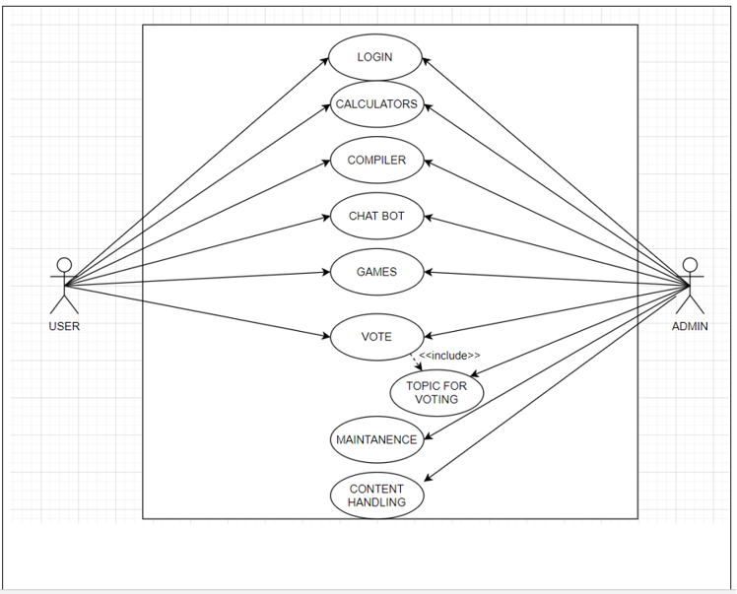

Figure [1]: Use case diagram

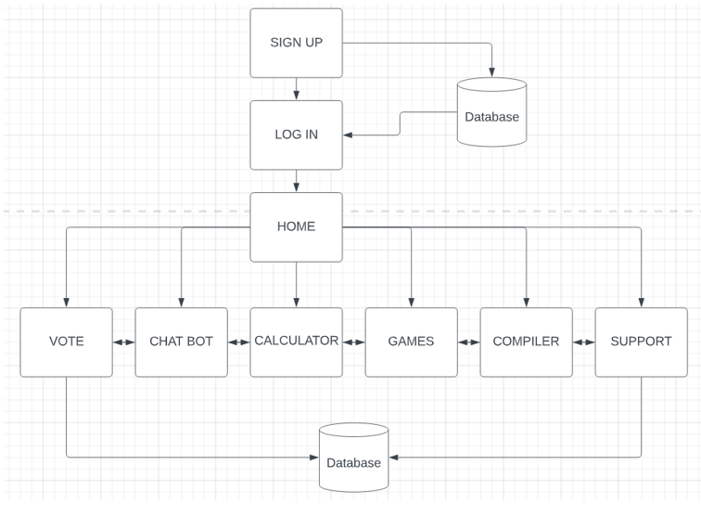

Figure [2]: dfd diagram

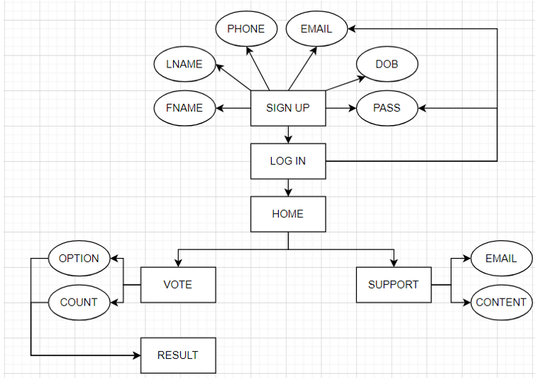

Figure [3]: ER diagram

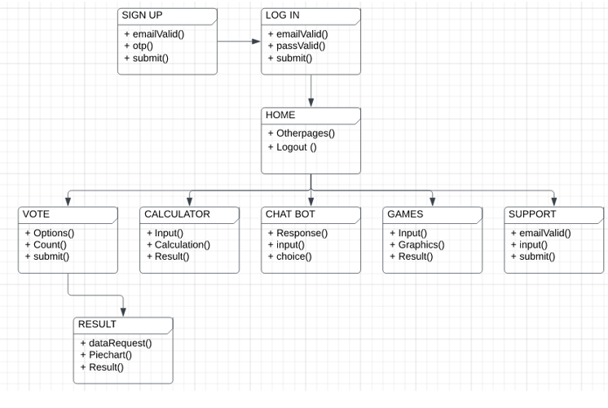Figure [4]: class diagram

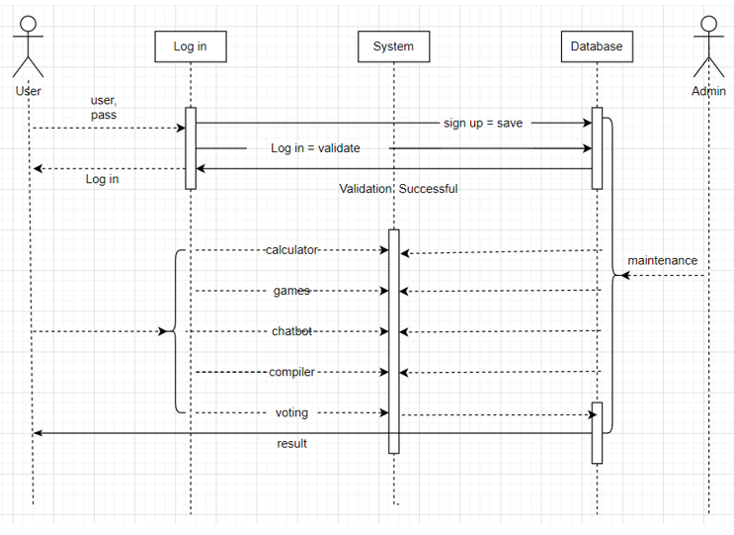

Figure [5]: sequence diagram

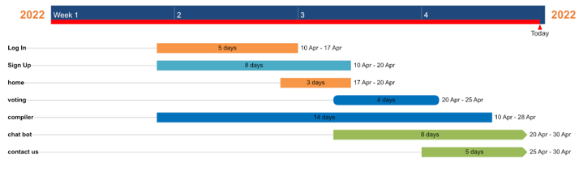Figure [6]: Gantt chart

**PROJECT SNAPS:**



Figure [7]: Login page

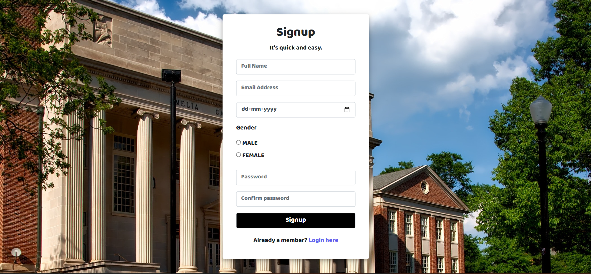

Figure [8]: sign up page

Figure [9]: `Forget Password

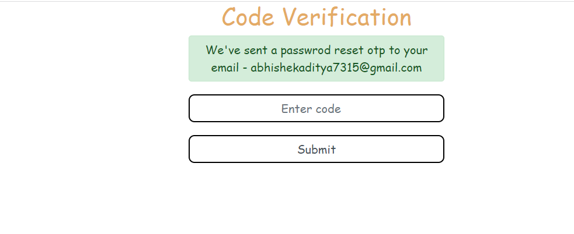

Figure [10]: Code Verification

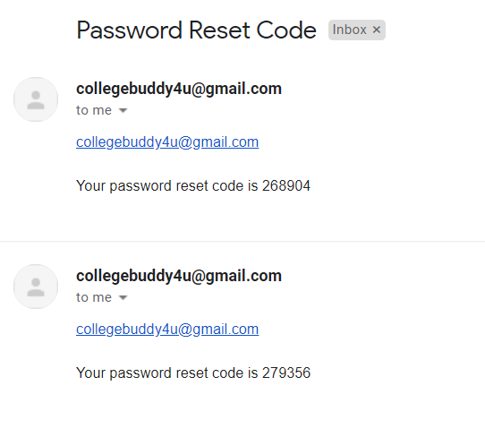

Figure [11]: Password reset code on email

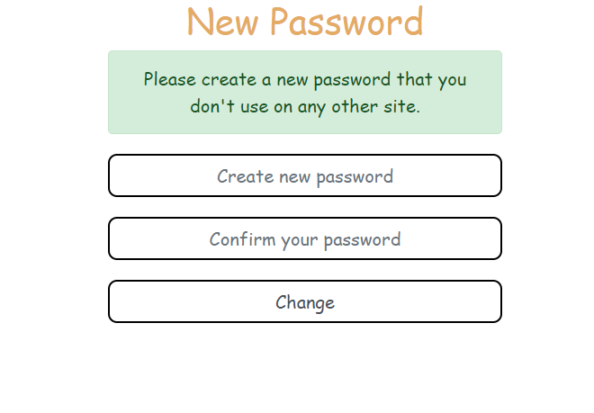Figure [12]: New password

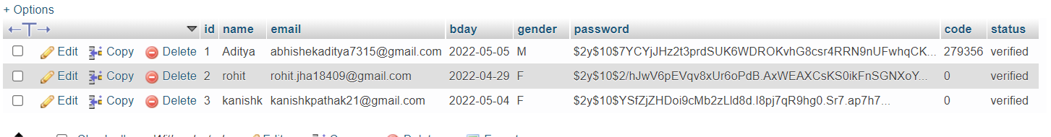

Figure [13]: database



Figure [14]: Home page

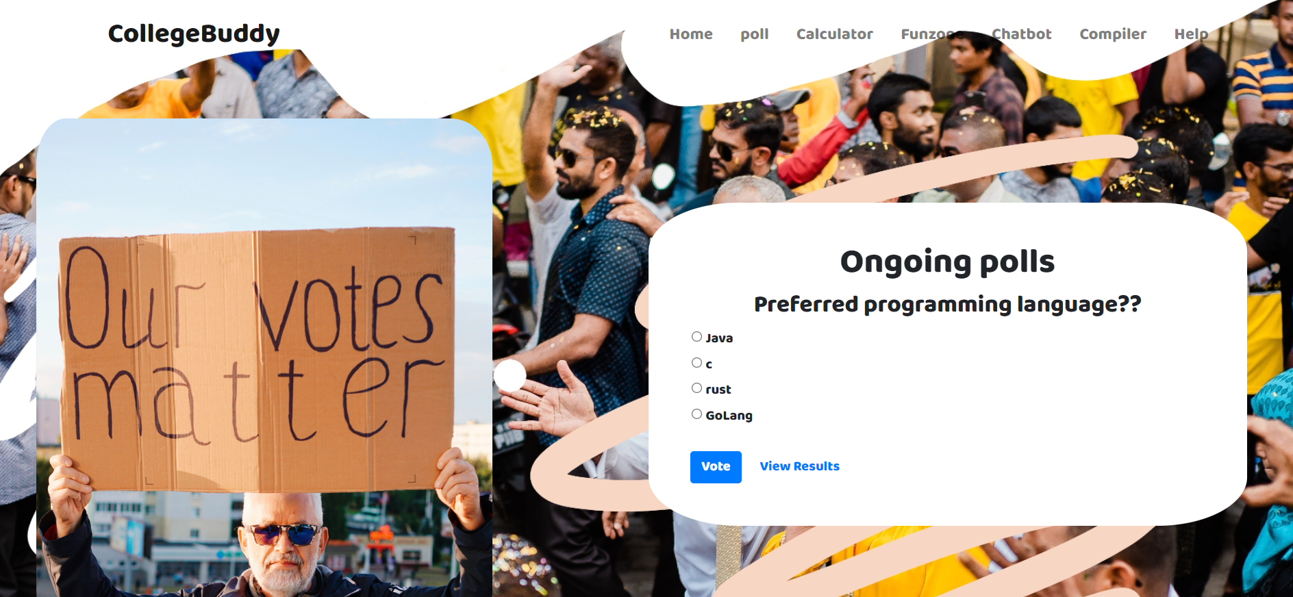

Figure [15]: voting page

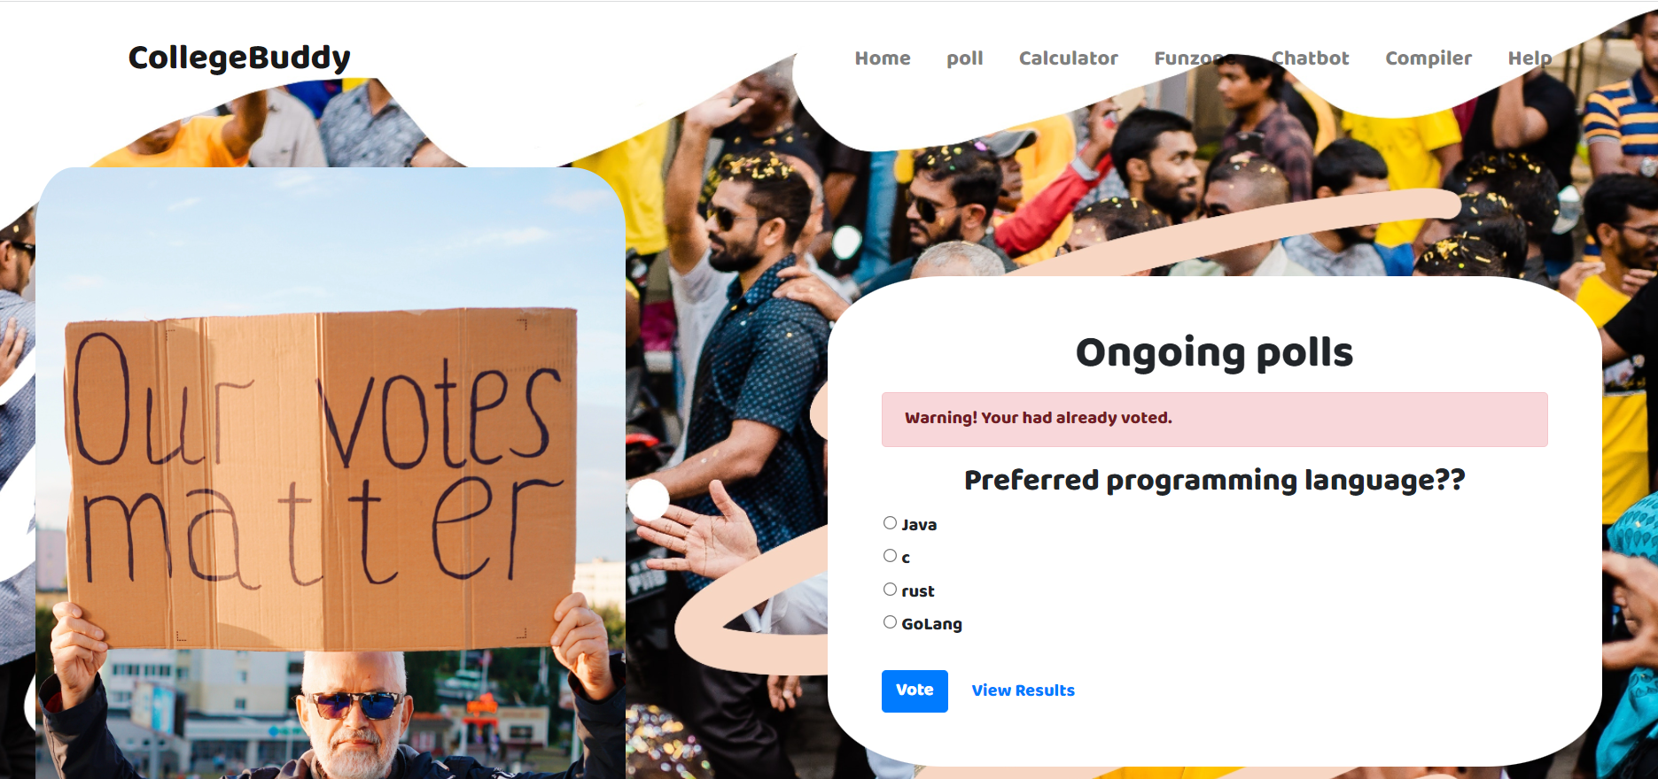

Figure [16]: voting page error

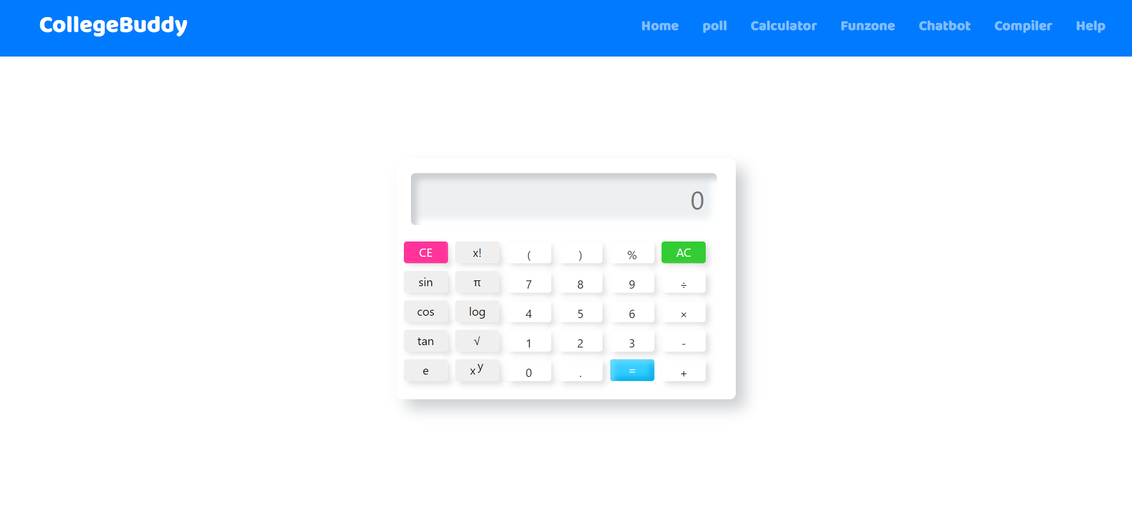

Figure [17]: calculator

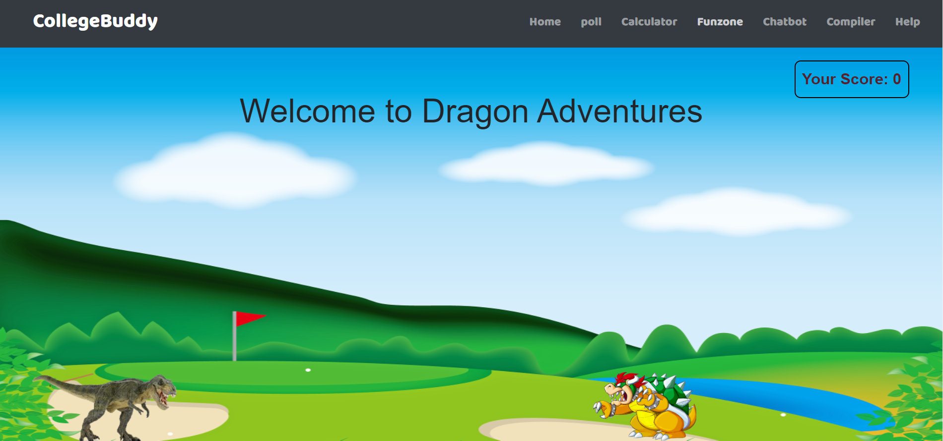Figure [18]: Game

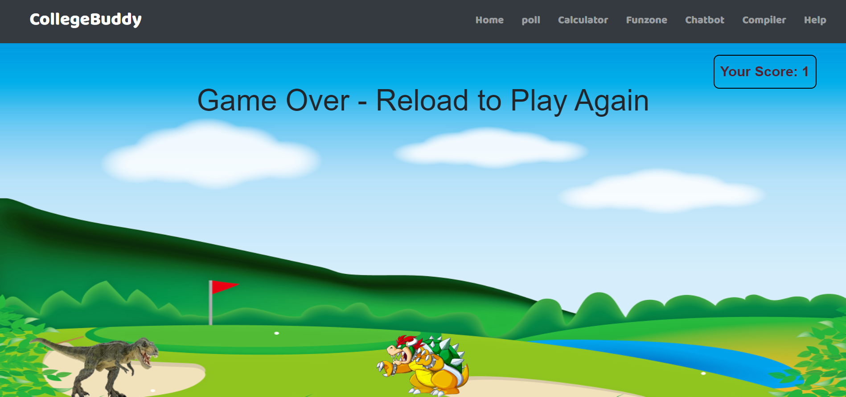Figure [19]: Game Failed

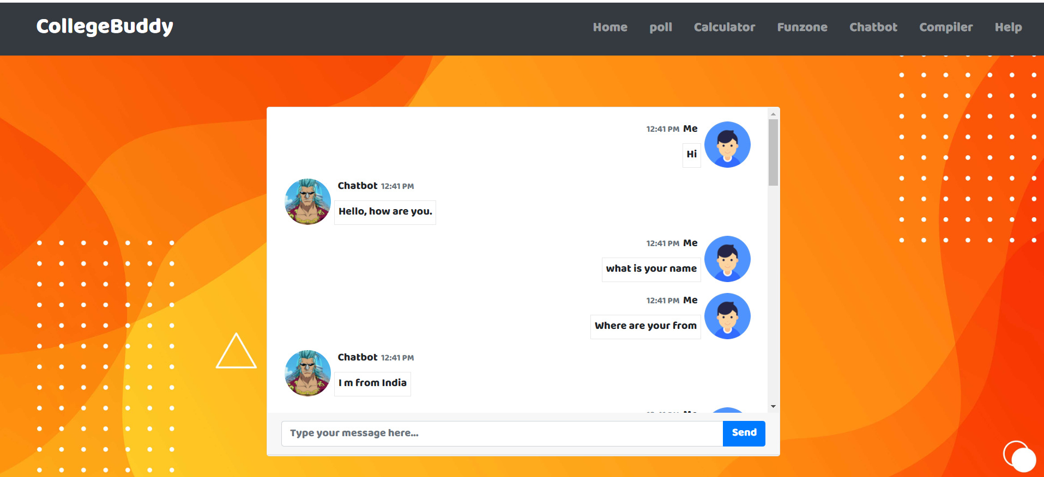Figure [20]: Chat bot

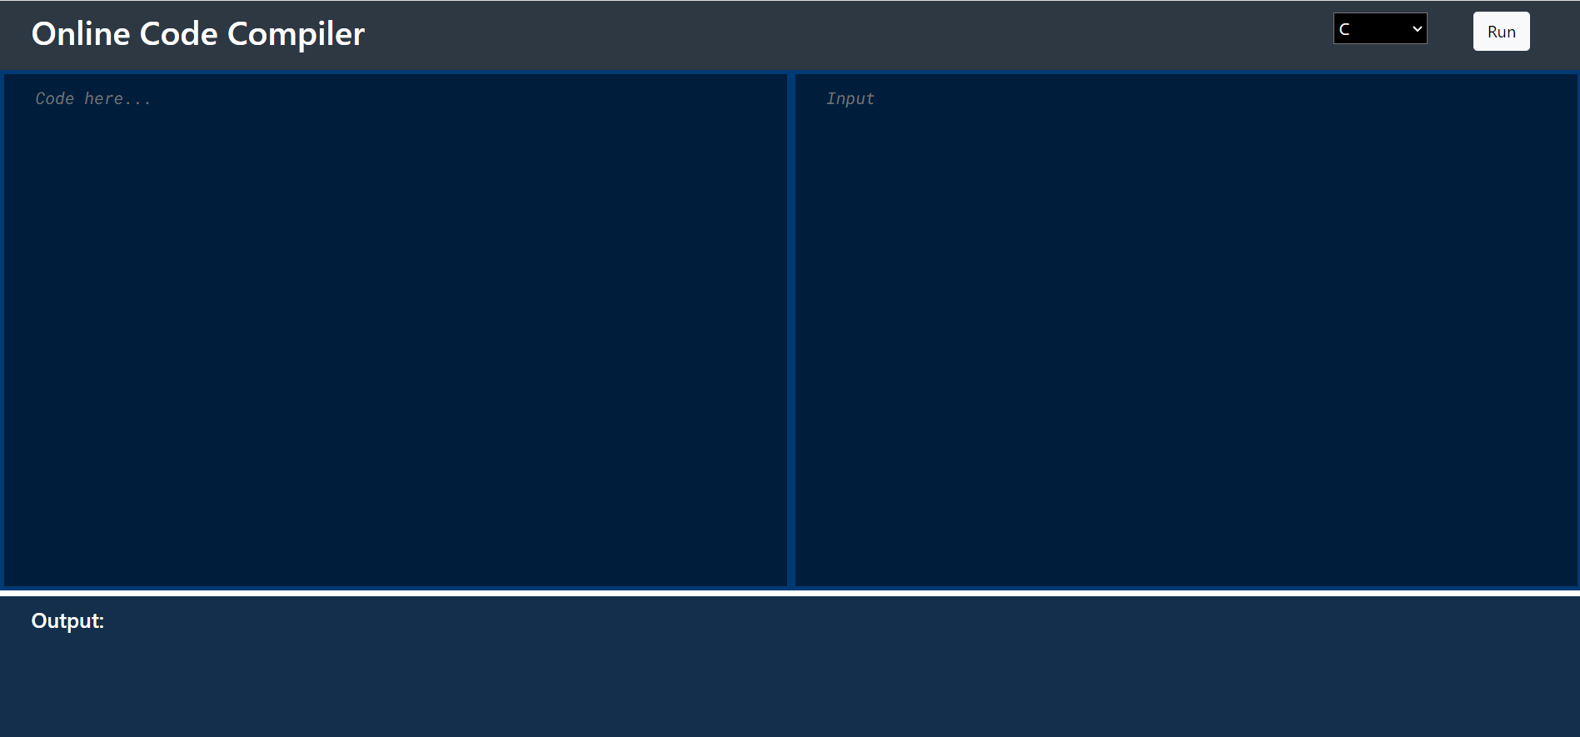Figure [21]: Compiler

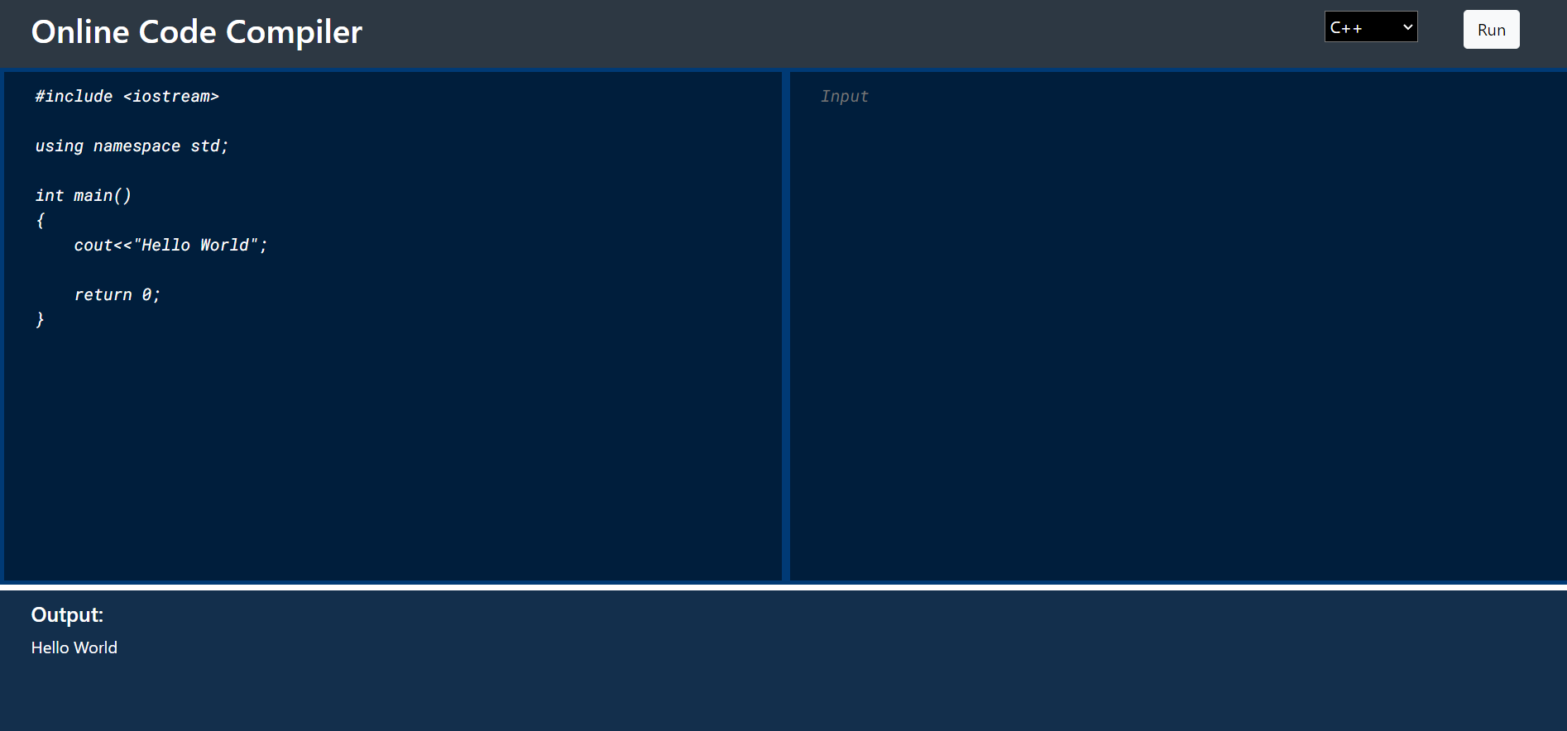Figure [22]: Compiler Code Runing

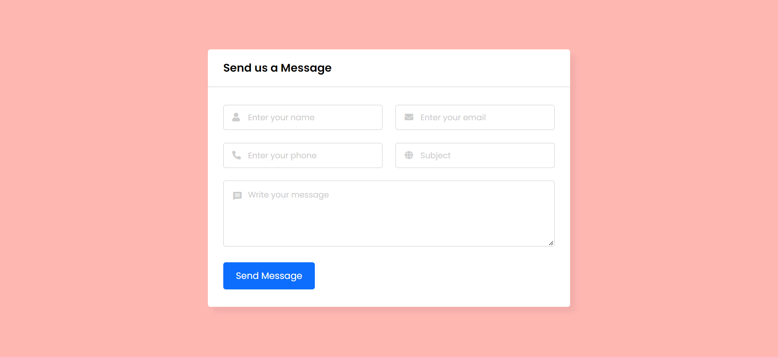Figure [23]: Contact us page

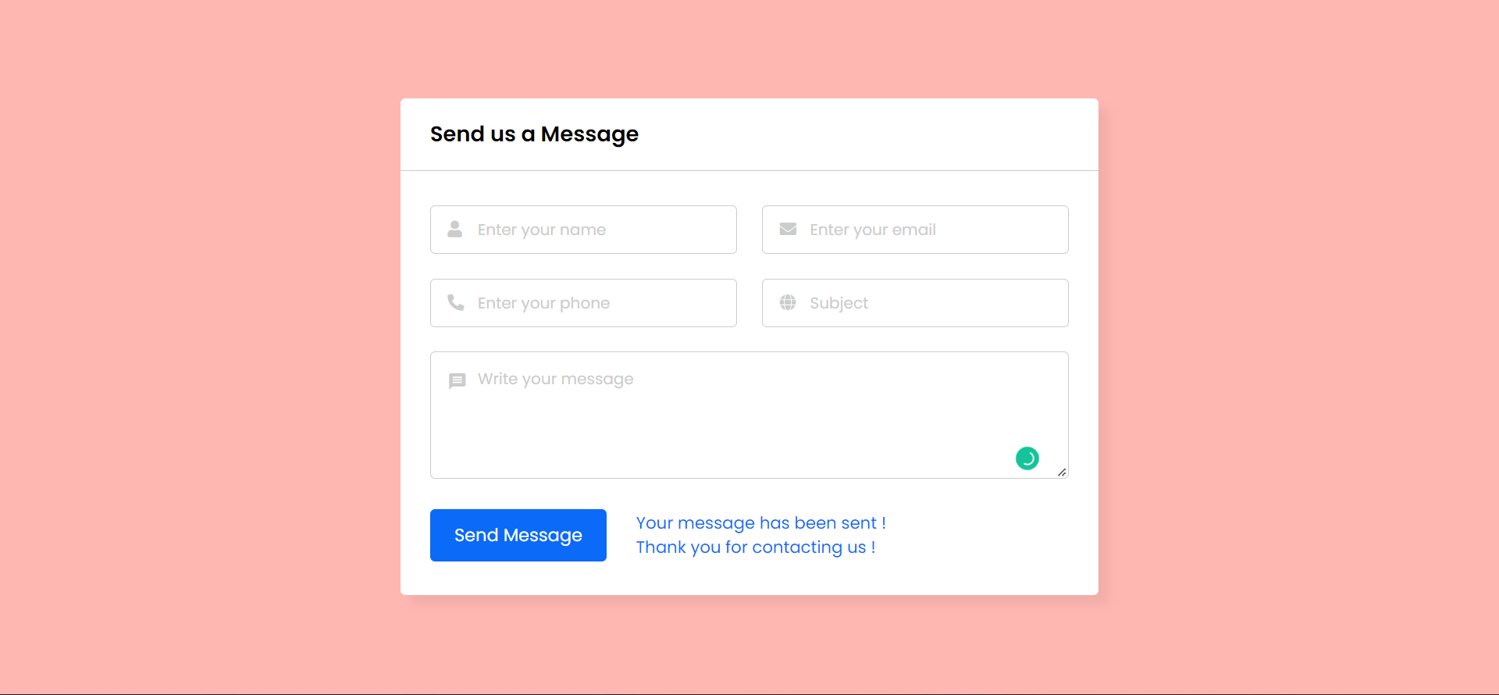Figure [24]: Message sent success

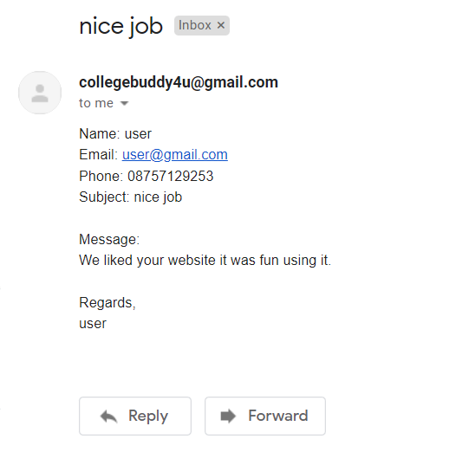

Figure [25]: Email received

1. **ANALYSIS AND VALIDATION**

**Requirement Analysis:**

In this I have collected all the information like how to create a strong login structure with PHP language and what all resources are needed in this project. Also, how this can be done in a proficient manner.

Some requirement for this project is:

**HTML 5:** HTML stands for Hyper Text Markup Language. It is used to design web pages using a markup language. HTML is the combination of Hypertext and Markup language. Hypertext defines the link between the web pages. A markup language is used to define the text document within tag which defines the structure of web pages. This language is used to annotate (at the note for computer) text so that a machine can understand it and manipulate text accordingly. Most of the markup (e.g. HTML) languages are human readable. The language uses tags to define what manipulation has to be done on the text. It is used for structuring and presenting the content on the web pages. HTML5 is the fifth version of HTML. Many elements are removed or modified from HTML5.

**Advantages of using HTML 5 are:**

It supports audio and video controls with the use of and tags It uses SQL databases and application cache to store offline data. Allows JavaScript to run in background. This is possible due to JS Web worker API in HTML5.Vector graphics is additionally an integral a part of HTML5 like SVG and canvas. It allows drag and drop effects.HTML5 allows to draw shapes like circle, rectangle, triangle etc. It supported by all new browser like Firefox, Mozilla, Chrome, Safari, etcHTML5 language is more mobile-friendly. Doctype declaration is quite simple and easy. New element for web structure like nav, header, footer etc. Character encoding is simple and easy. One can track the Geolocation of a user easily by using JS geolocation API. It is capable of handling inaccurate syntax. Attributes of charset, async and ping are a part of HTML 5.

**Cascading Style Sheets (CSS)** is a stylesheet language used to describe the presentation of a document written in HTML or XML (including XML dialects such as SVG, MathML or XHTML). CSS describes how elements should be rendered on screen, on paper, in speech, or on other media.

CSS is among the core languages of the open web and is standardized across Web browsers according to W3C specifications. Previously, development of various parts of CSS specification was done synchronously, which allowed versioning of the latest 5 recommendations. You might have heard about CSS1, CSS2.1, CSS3. However, CSS4 has never become an official version.

**Advantages of CSS3:**

The scope of the specification increased significantly and the progress on different CSS modules started to differ so much, that it became more effective to develop and release recommendations separately per module. Instead of versioning the CSS specification, W3C now periodically takes a snapshot of the latest stable state of the CSS specification

**PHP:** PHP is a general-purpose scripting language geared toward web development. It was originally created by Danish-Canadian programmer Rasmus Lerdorf in 1994. The PHP reference implementation is now produced by The PHP Group. PHP originally stood for Personal Home Page but it now stands for the recursive initialism PHP: Hypertext Preprocessor.

PHP code is usually processed on a web server by a PHP interpreter implemented as a module, a daemon or as a Common Gateway Interface (CGI) executable. On a web server, the result of the interpreted and executed PHP code – which may be any type of data, such as generated HTML or binary image data – would form the whole or part of an HTTP response. Various web template systems, web content management systems, and web frameworks exist which can be employed to orchestrate or facilitate the generation of that response. Additionally, PHP can be used for many programming tasks outside the web context, such as standalone graphical applications and robotic drone control. PHP code can also be directly executed from the command line.

**SQL:** Structured Query Language) is a domain-specific language used in programming and designed for managing data held in a relational database management system (RDBMS), or for stream processing in a relational data stream management system (RDSMS). It is particularly useful in handling structured data, i.e., data incorporating relations among entities and variables. SQL offers two main advantages over older read–write APIs such as ISAM or VSAM. Firstly, it introduced the concept of accessing many records with one single command. Secondly, it eliminates the need to specify how to reach a record.

**Advantages of SQL:**

It is widely used in the Business Intelligence tool.

Data Manipulation and data testing are done through SQL.

Data Science tools depend highly on SQL. Big data tools such as Spark, Impala are dependent on SQL. It is one of the demanding industrial skills.

**JavaScript:** JS is a programming language that is one of the core technologies of the World Wide Web, alongside HTML and CSS. Over 97% of websites use JavaScript on the client side for web page behavior, often incorporating third-party libraries. All major web browsers have a dedicated JavaScript engine to execute the code on users' devices.

JavaScript is a high-level, often just-in-time compiled language that conforms to the ECMAScript standard. It has dynamic typing, prototype-based object-orientation, and first-class functions. It is multi-paradigm, supporting event-driven, functional, and imperative programming styles. It has application programming interfaces (APIs) for working with text, dates, regular expressions, standard data structures, and the Document Object Model (DOM).

The ECMAScript standard does not include any input/output (I/O), such as networking, storage, or graphics facilities. In practice, the web browser or other runtime system provides JavaScript APIs for I/O.

**Advantages of JS are:**

● Speed. Client-side JavaScript is very fast because it can be run immediately within the client-side browser. Unless outside resources are required, JavaScript is unhindered by network calls to a backend server.

● Simplicity. JavaScript is relatively simple to learn and implement.

● Popularity. JavaScript is used everywhere on the web.

● Interoperability. JavaScript plays nicely with other languages and can be used in a huge variety of applications.

● Server Load. Being client-side reduces the demand on the website server.

● Gives the ability to create rich interfaces

**Xampp:** It is a free and open-source cross-platform web server solution stack package developed by Apache Friends, consisting mainly of the Apache HTTP Server, MariaDB database, and interpreters for scripts written in the PHP and Perl programming languages. Since most actual web server deployments use the same components as XAMPP, it makes transitioning from a local test server to a live server possible.

XAMPP's ease of deployment means a WAMP or LAMP stack can be installed quickly and simply on an operating system by a developer, with the advantage that common add-in applications such as WordPress and Joomla! can also be installed with similar ease using Bitna mi.

**Advantages of XAMPP:** It is free and easy to use and easily available for Windows, Linux and Mac OS. It is a beginners friendly solution package for full stack web development. It is a open-source software package which gives a easy installation experience.

**Bootstrap 5:** Bootstrap is an HTML, CSS & JS Library that focuses on simplifying the development of informative web pages (as opposed to web apps). The primary purpose of adding it to a web project is to apply Bootstrap's choices of color, size, font and layout to that project. As such, the primary factor is whether the developers in charge find those choices to their liking. Once added to a project, Bootstrap provides basic style definitions for all HTML elements. The result is a uniform appearance for prose, tables and form elements across web browsers. In addition, developers can take advantage of CSS classes defined in Bootstrap to further customize the appearance of their contents. For example, Bootstrap has provisioned for light- and dark-colored tables, page headings, more prominent pull quotes, and text with a highlight.

Bootstrap also comes with several JavaScript components in the form of jQuery plugins. They provide additional user interface elements such as dialog boxes, tooltips, and carousels. Each Bootstrap component consists of an HTML structure, CSS declarations, and in some cases accompanying JavaScript code. They also extend the functionality of some existing interface elements, including for example an auto-complete function for input fields.

**Advantages of bootstrap 5:**

● New off canvas menu component

● Removing dependence on jQuery in favor of vanilla JavaScript

● Rewriting the grid to support responsive gutters and columns placed outside of rows

● Migrating the documentation from Jekyll to Hugo

● Dropping support for Internet Explorer

● Moving testing infrastructure from QUnit to Jasmine

● Adding custom set of SVG icons

● Adding CSS custom properties

● Improved API

● Enhanced grid system

● Improved customizing docs

● Updated forms

● RTL support

**Algorithm of compiler:**

1) It's all starts with home page where user have to provide the info about the code, input, programming language in a HTML form.

2) Home page is an ejs file which contains two HTML textarea one for code, another for input which are both initially empty.

3) It also contains HTML select input for selecting the programming language which is C by default and run button which submits the form.

4) Then we have the output div which shows the output using paragraph tag(<p></p>) which is also empty initially.

5) When the user submits the code and make a post request to the server.

6) Now at the server we retrieve three things code, language and input.

7) Then we have a function name executeCode to execute the code by making an https post request to codex API using axios library to which we pass all the three things which user submitted i.e. code,input,language.

8) The Api request returns us the output of the code and we store the output in a variable named output. If the Api call didn’t get executed successfully then we store “Some error occurred :(” in the output variable.

9) Now it's time to load the load the home page again with the output.

10) We now load the home page again by passing four things using ejs of which three are the code, language, input entered by the user and another one is output.

11) Now the home page is loaded again in which the code, input, output is set to the value sent by the server which were initially empty and language is also change to the same which was sent by the server in “language” parameter using ejs JavaScript logical code.

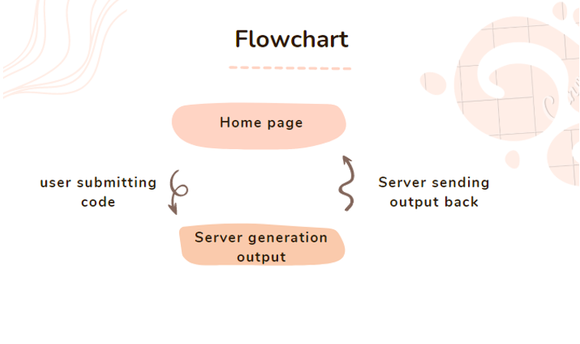

Figure [26]: compiler flow

**Unit Testing:**

UNIT TESTING is a type of software testing where individual units or components of a software are tested. The purpose is to validate that each unit of the software code performs as expected. Unit Testing is done during the development (coding phase) of an application by the developers. Unit Tests isolate a section of code and verify its correctness. A unit may be an individual function, method, procedure, module, or object.

* Checking proper connection of html and database
* Fileds and their values
* Proper log in and sign-up working
* Sending of otp
* Working of error controls
* Functioning of game
* Registration of new user
* Counting of vote
* Configuration of xampp
* Proper working of buttons

**INTEGRATION TESTING:**

It is defined as a type of testing where software modules are integrated logically and tested as a group. A typical software project consists of multiple software modules, coded by different programmers. The purpose of this level of testing is to expose defects in the interaction between these software modules when they are integrated.

Checking that, whether the project work flow is proper or not. whether the end project is fully functional or not. Lastly, checking whether any evolutionary step required or not.

1. **CONCLUSION AND FUTURE WORK:**

When we started working on this project our aim was to make a website which would merely be used to convert pdfs to word and vice versa but given the time we had in our hands we thought to make a project which would help us, the students. We started to look at things very minutely to figure out the things that could help out students like us in our daily life , this was when my friends and I decided to make a website with many utilities like compiler , a polling system to get a general idea of what things we prefer , related to computer science and things which are currently new to the industry then we added a chatbot to help the students to get important information i.e. important announcements from the university, our upcoming exams etc. We also added a fun zone which includes games for the user to enjoy the website and chill. In the future we want to strengthen the security of our website and introduce more specific addons to help the students in the CS department by adding a page which will show upcoming hackathons which students can attend, notify them of job openings, articles regarding how to get started with different tech stacks and articles of our seniors about how they made it to the top MNC’s

**References**

1. CUSTUDENTSZONE. (n.d.). Cu Student’s Zone. Retrieved March 31, 2022, from <https://custudentszone.azureedge.net/>
2. HTMLGames.com - Games for your site. (n.d.). HTML Games. Retrieved April 1, 2022, from <https://www.htmlgames.com/html5-games-for-your-site/>
3. Grow!, L. S. A. (2021, March 20). Online Voting System in PHP | Part 1 Tutorial | PHP Mini Project with Source Code | HTML Basics. YouTube. Retrieved April 1, 2022, from <https://www.youtube.com/watch?v=3x697N7sHl8&feature=youtu.be>
4. C. (2020, August 22). I Created an Action Game in Pure HTML, CSS & JavaScript - Game Development Tutorial in Hindi. YouTube. Retrieved April 17, 2022, from <https://www.youtube.com/watch?v=_OHRerLS4dI&feature=youtu.be>
5. C. (2021, June 16). How to configure XAMPP to send Mail from Localhost in PHP ? CodingNepal. Retrieved May 5, 2022, from <https://www.codingnepalweb.com/configure-xampp-to-send-mail-from-localhost/>